**Create a Page Layout using SharePoint Designer**

Open SharePoint designer 🡪 Open Publishing Portal Site collection

Select Page layouts

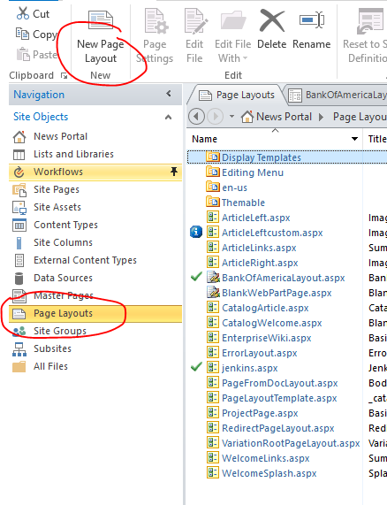

Create New Page Layout

* Enter url BankOfAmericalayout.aspx
* Enter Title Bank Of America layout

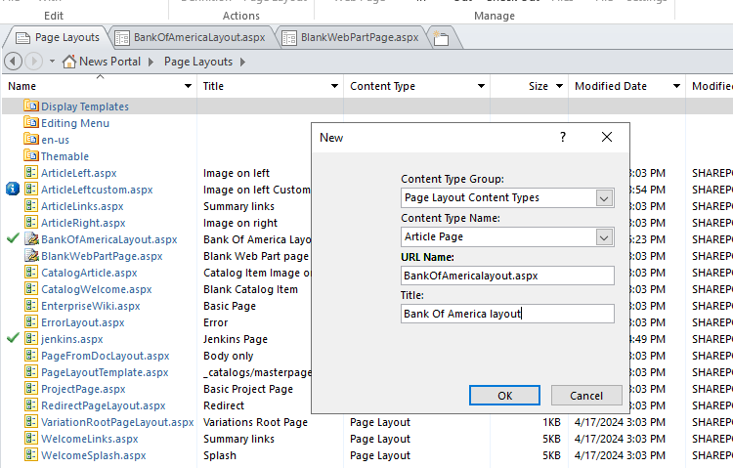

Open the Page layout file and Paste below code inside PlaceHolderMain

<asp:Content ContentPlaceholderID="PlaceHolderMain" runat="server">

<div>

<h1>Welcome to SharePoint 2019 Training</h1>

<p>Organizations use Microsoft SharePoint to create websites. You can use it as a secure place to store, organize, share, and access information from any device. All you need is a web browser, such as Microsoft Edge, Internet Explorer, Chrome, or Firefox. Want to learn more? Get started with SharePoint.

Take a look at the latest version of SharePoint. When you create a new team site, this is what you’ll see for SharePoint and SharePoint Server 2019.

</p></div>

<div>

<WebPartPages:WebPartZone runat="server" Title="Top Web part Zone" ID="Top">

<ZoneTemplate>

</ZoneTemplate></WebPartPages:WebPartZone>

<WebPartPages:WebPartZone runat="server" Title="Middle Web part Zone" ID="Middle">

<ZoneTemplate>

</ZoneTemplate></WebPartPages:WebPartZone>

<WebPartPages:WebPartZone runat="server" Title="Footer Web part Zone" ID="Footer">

<ZoneTemplate>

</ZoneTemplate></WebPartPages:WebPartZone>

</div>

</asp:Content>

Save it

**Check in and Publish the Layout**

Open the site in browser and go to sit settings

Select **Master pages and page layouts** under web Galleries

Check in the BankOfAmericalayout.aspx

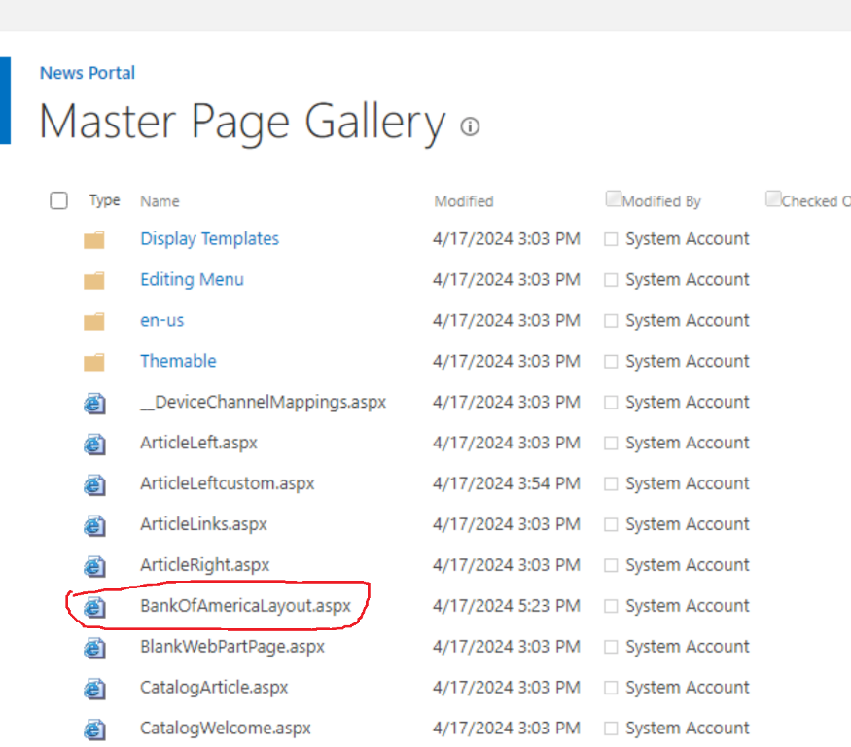

Publish it

**Create a Page using out custom Layout**

Then open Page Library and create new Article page

* select BOA Page layouts

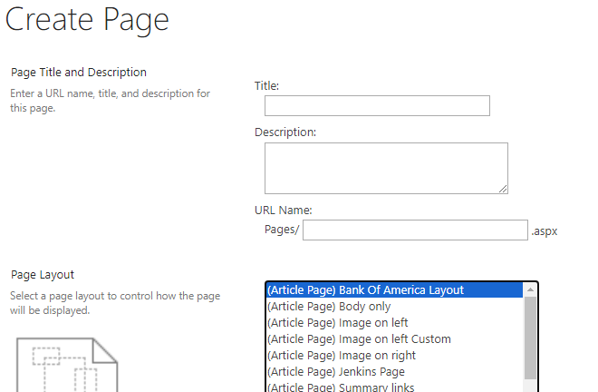

Click Create to create a Page

Add webparts as per your wish

Save it

Publish it

